Merchandise Vendor
Reporting Manual

Cueto Event Management System | February 2016
Table of Contents
Introduction 3
Contact Info 3
Terms of Use 3
Home Page 4
Tools and Reports 5
Movement Report 5
Filters 5
Display Settings 5
Tools 5
Inventory Reduction 6
My IR Batches 8
Movement Timeline 9
Mobile Item Scan Tool 10
Android Instructions 10
Apple Instructions 10
Unrecognized Device 10
Final Counts (Usually Hidden) 11
E-Mail and Text Notifications 12
Vendor Notification Signup Form 12

Introduction
This guide is intended to cover the merchandise vendor reporting interface for the Cueto Event Management Software. The guide is current as of February 2016 and new versions will be published for each major revision.

Contact Info
Cueto & Cueto, Inc. is the company responsible for developing, maintaining and hosting the Cueto Event Management Software. We welcome – and appreciate - your questions and feedback about the software, website and manual. The best way to get in touch with us is through e-mail at john@cuetoems.com. You can also use our contact form:
http://www.cuetoems.com/Contact.aspx
If you’re writing about a specific event, please put the name of the event in the subject of the message so the correct person gets your message. Due to our travel schedule, it may take us several days to respond.

Terms of Use
This document in its entirety is Copyright 2016 Cueto & Cueto, Inc. It may be copied or distributed, in part or in whole, by any of our customers, or agents acting on their behalf, for purposes of education and training.
This document may not be used for purposes of reverse engineering or duplication of the Cueto Event Management Software.
The most recent version can always be found at:
http://www.cuetoems.com/Help.aspx

Home Page
Your home page is your customized portal to the event. It’s broken up into four sections:
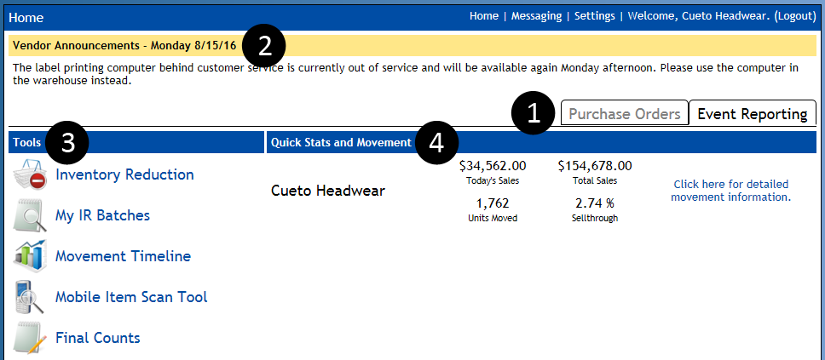
- View Tabs – Switch between the Purchase Order view and the Event Reporting view. If you’re using the online purchase order system, you’ll get separate instructions from your contact at the event.
- Announcements – Event and Cueto staff members can update this area with announcements, although it is often hidden when there is no urgent news.
- Tools – Depending on which tools the event has made available to merchandise vendors, you will see up to five icons here. See the corresponding sections later in this document for instructions and examples.
- Quick Stats and Movement – Gives you a real time summary of your sales, broken down by company if you represent more than one. The movement link to the right goes to a detailed per-item movement summary; see the Movement Report section for more information.

Tools and Reports

Movement Report
The movement report allows you to explore your sales data in a variety of formats and groupings, with a number of optional filters, and is your main tool for understanding the performance of your product at the event. When you load it for the first time you’ll see all your items grouped by category:
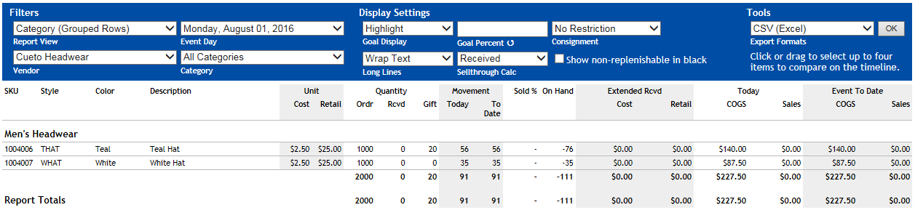

Filters
You can change whether you see individual items or categories and whether the report should give an overview or focus on best/worst selling items. You can also limit the data to a specific day and category or change vendors if you represent multiple companies.

Display Settings
You can change whether the report should highlight items in red or green based on a goal you set, highlighting for consignment and non-replenishable items and how to handle items with long lines of text.

Tools
You can export the data in various formats as well as click up to four lines in the report to highlight them. Once you’ve highlighted at least one item, a compare button will appear that takes you to the Movement Timeline tool (see below) with your selections already filled in.
Although you can print this page directly, most people prefer to save the report as a PDF via the Export dropdown and print that.

Inventory Reduction
This tool allows you to remove items from inventory, such as pulling staff uniforms or gifts. Clicking the icon will prompt you to create a new batch:
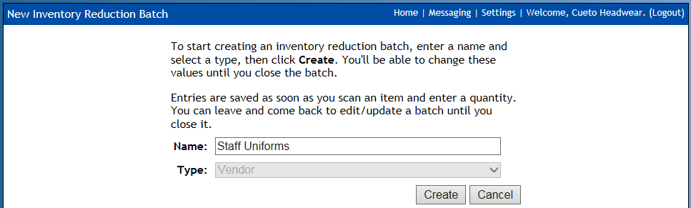
The Type will be set to Vendor and can’t be changed. Enter a name for the batch and then click Create. An empty inventory reduction batch screen will appear:
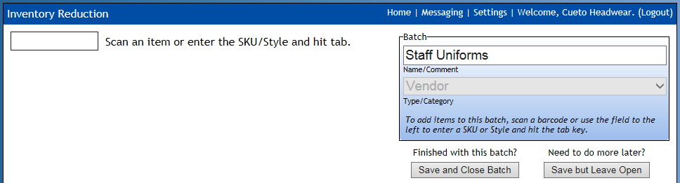
Scan or manually enter the first barcode. If you enter an unrecognized barcode or try to scan another vendor’s product, you’ll see an error. If you enter a valid barcode, you’ll see the style number and the system will ask for the quantity:
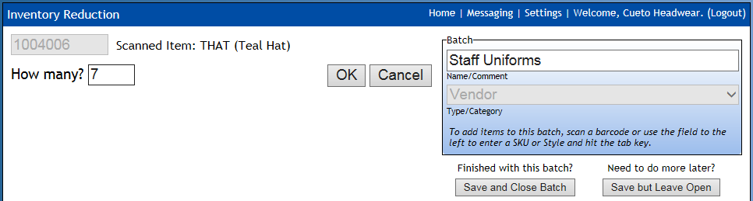
Always verify the style number. If you made a mistake, hit Cancel and the nothing will be added or changed on the current batch. If everything looks good, type in the quantity and hit Enter or click OK. You’ll see the item added to the batch on the right side:
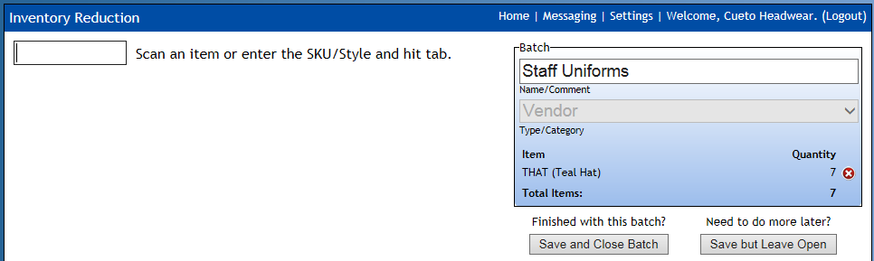
Repeat the last two steps while you have items to add to the batch. When you’re finished, click Save and Close Batch if you won’t need to add anything else to this batch in the future. If you might need to add or edit the batch in the future, you can click Save but Leave Open. Most events prefer the batch to be closed as the items leave your possession so if you’re going to be pulling uniform items each day or giving gifts throughout the week, please make a new batch each time.
After you’re finished, you’ll see a printable confirmation screen:
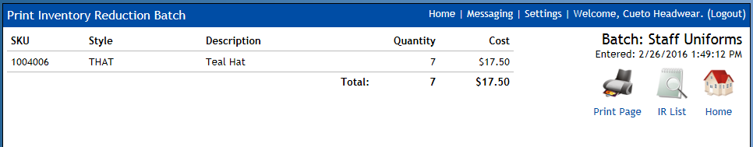
You can print a copy for your records, click IR List to see your list of inventory reduction batches (see next section) or click Home to return to the home page.

My IR Batches
You can use this tool to look at any inventory reductions you’ve done in the past or edit batches you’ve left open. When you first load it, you’ll see a collapsed list of your batches with some basic information and item totals:
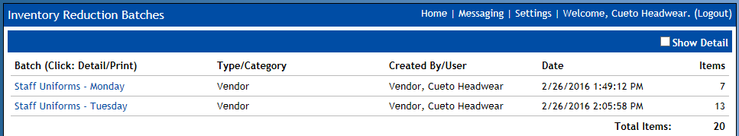
Clicking the Show Detail checkbox will expand each batch, showing the contents:
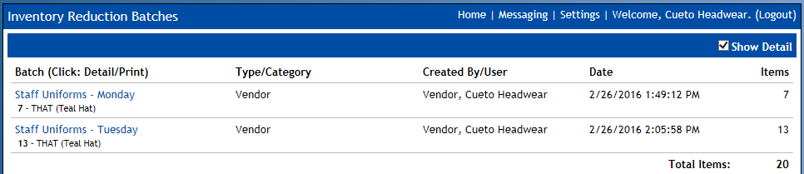
Clicking on the name of a batch will take you to the printable confirmation screen you saw when you first created the batch. If you left the batch open, you’ll see an Edit Batch icon in addition to the normal three.

Movement Timeline
This tool allows you to compare movement data graphically. When you load it for the first time you’ll see your total sales broken down by day:
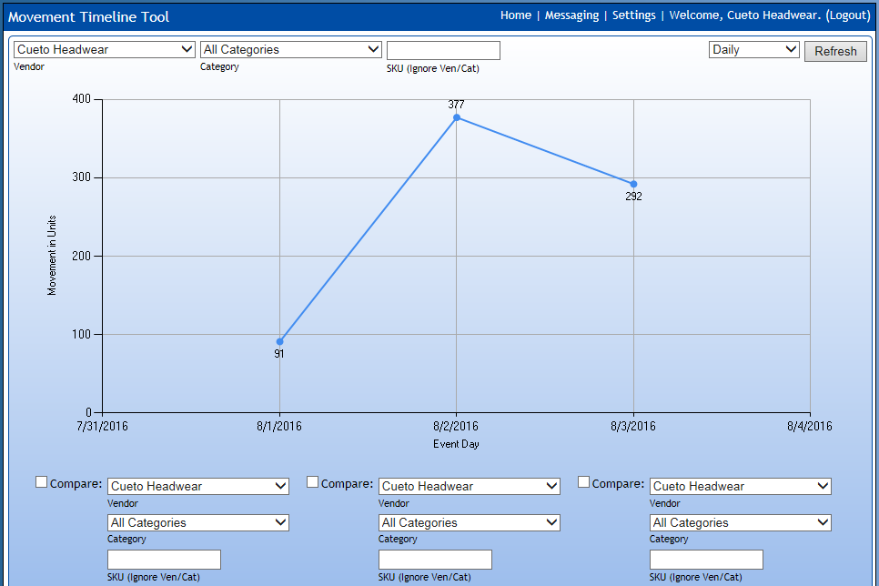
You can use the category and SKU filters to restrict the data, as well as select up to three more of your vendors, categories or SKUs to compare using the three groups of fields below the graph. You can also toggle between a Daily and Cumulative display using the dropdown next to the Refresh button.

Mobile Item Scan Tool
When you’re out on the floor and you need to get information about an item quickly without looking through your movement reports, the Mobile Item Scan Tool can be used from any Android or Apple mobile device, including many tablets.

Android Instructions
To use the tool on Android devices, please install the app Barcode Scanner by ZXing for free from the Google Play Store.
Clicking the icon with the app installed will show a screen with some text and two links. Click the Scan Item and follow the on-screen instructions to capture the barcode. If the item scans correctly, is recognized by our system and your have access to view the item, you’ll see a variety of sales and movement information. If not, you’ll see an error messaging explaining the problem.

Apple Instructions
To use the tool on Apple devices, please install the app Barcode Scan to Web by Berry Wing for $2.99 from the App Store. Save yourself some time by setting our login page as the home page for this app.
Clicking the icon with the app installed will show a screen with a single blank text box. Tap the scan button that is part of the app and follow the on-screen instructions to capture the barcode. If the item scans correctly, is recognized by our system and your have access to view the item, you’ll see a variety of sales and movement information. If not, you’ll see an error messaging explaining the problem.

Unrecognized Device
Trying to load this tool on a computer or unsupported mobile device such as a Blackberry or Windows phone will show an unrecognized device error message because the tool uses barcode scanning tools that are specific to the Android and Apple platforms. Windows Phone support will be coming in the future.
If you’re using an Android or Apple device and get this error message, please contact a Cueto & Cueto staff member for help.

Final Counts (Usually Hidden)
This tool can be used in two ways. Events that choose to have vendors enter final counts online will place the screen in edit mode, allowing you to enter these quantities:
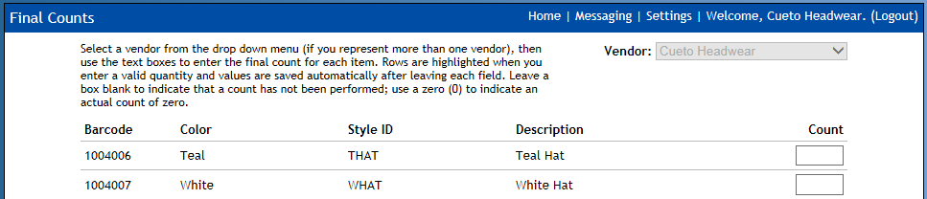
Quantities you enter are automatically saved as you move between fields. A blank box indicates that an item hasn’t been counted; please enter 0 for items that have an actual count of zero.
Events that choose to have vendors submit counts on paper forms may still make the tool available to verify counts in read-only mode:
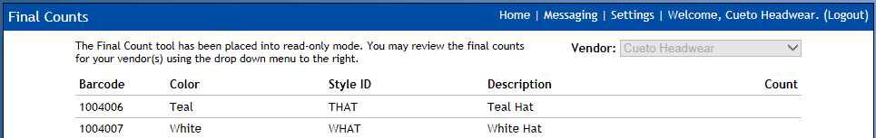

E-Mail and Text Notifications
We understand that it’s easy to lose track of time when you’re busy and it can be hard to make it to a computer to look at your sales figures. Although you can access the website from most phones, we can send a brief summary of your sales figures every hour, at 15 minutes after the hour, as an e-mail or text message.
To sign up for these notifications, please fill out and tear off the bottom half of this page. You can bring it to any Cueto & Cueto staff member or leave it at Customer Service.
Important: You are responsible for all charges related to receiving text messages.

Vendor Notification Signup Form

Company Name:

Your Name:

For each person who should receive these notifications, please list a phone number (including area code) or e-mail address:

